Mettler Toledo GSP Configuration Tool – User’s Guide

Version 1.0 2014-01-17

# Installation

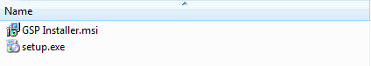

To start the installation of the GSP Configuration Tool, open the install directory and double-click on the setup.exe file.

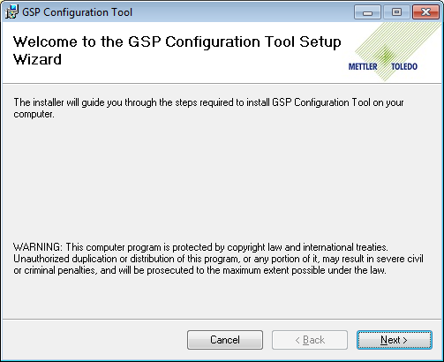

Click Next.

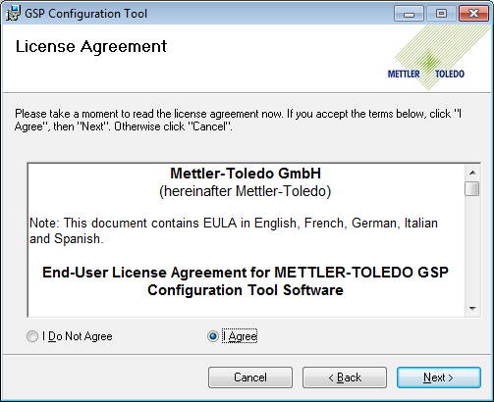

Read the license agreement and select “I Agree” to continue. Click Next.

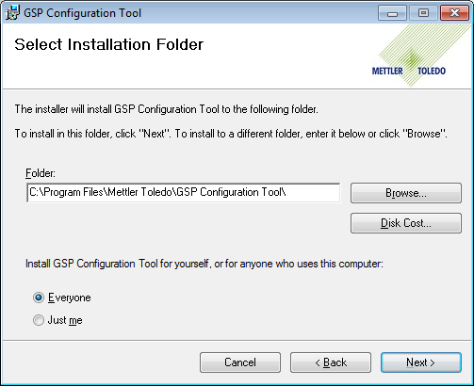

Select the installation folder where you would like the installer to install the files, select who can access the program, and click Next to continue.

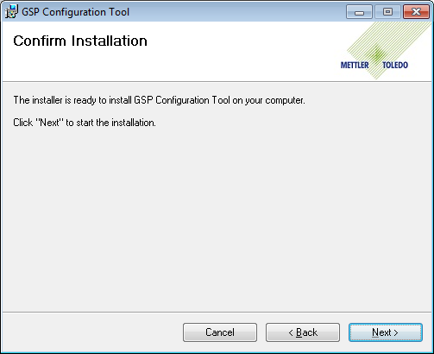

After configuring the setup options, click Next to continue.

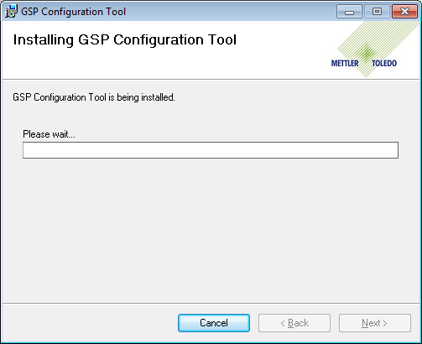

The installation can take several minutes to complete and a User Account Control popup window may appear. Select "Yes” on the popup window to continue the installation.

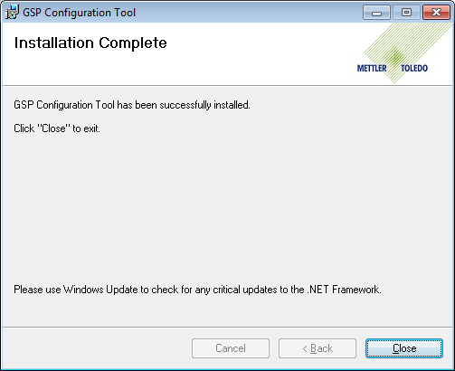

When the installation is complete, press Close to exit the installation.

**Starting the Configuration Tool**

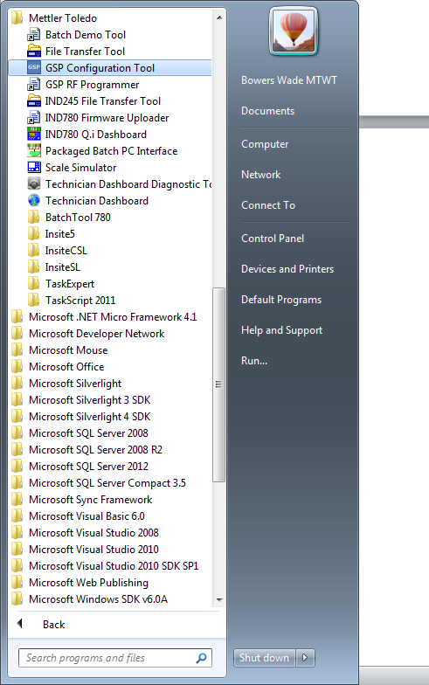

To start the GSP Configuration Tool, select Start > All Programs > Mettler Toledo > GSP Configuration Tool.

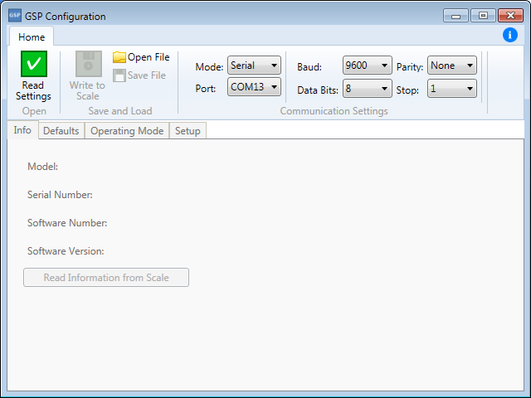

The GSP Configuration Tool window.

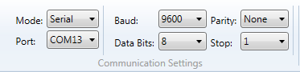

The GSP Configuration Tool Communication Settings panel. These options must be set to match the communication settings of the GSP scale before communication can begin.

# Reading from a Scale

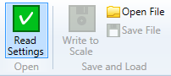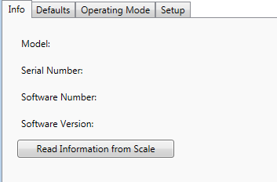

To read settings from the scale, you can either click the Read Settings button in the Ribbon control or click the Read Information from Scale button in the Info tab.

*Note: The Info tab is disabled until a valid configuration is either read from the scale or a GSP configuration file is opened.*

# Writing to a Scale

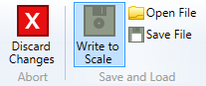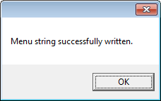

To write to the scale, click the Write to Scale button. If the operation is successful, a popup will display, “Menu string successfully written.”

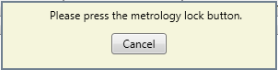

You may encounter a message that says, “Please press the metrology lock button,” if a setting behind the metrology lock is changed. Press the metrology lock button on the GSP to continue.

# Reading from a File

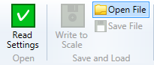

To read settings from a file, click the Open File button in the Ribbon control.

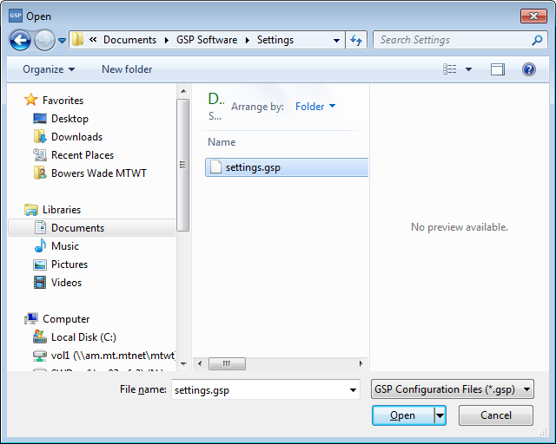

A file selection window is opened. Select the desired *.gsp file and click Open.

# Saving to a File

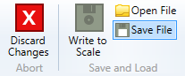

To save a configuration, click the Save File button in the Ribbon control.

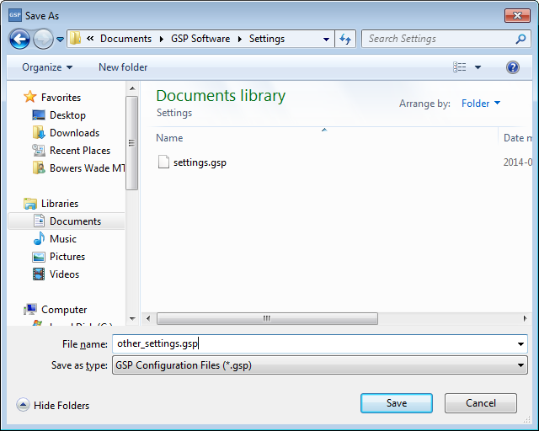

Enter the desired file name and click the Save button.

# Errors

* Port name not found in list.
  + Make sure the GSP scale is attached and reopen the GSP Configuration Tool.
* Could not open serial port.
  + Make sure the GSP scale is attached and reopen the GSP Configuration Tool.
* Serial port read timeout.
  + Make sure the GSP scale is attached and reopen the GSP Configuration Tool.